Lab 3: Torque Control of Permanent-Magnet Synchronous Motors

Connor Ricotta

400199761

# Introduction:

The purpose of this lab is to further investigate control strategies explored in the previous lab, specifically implementing a MTPA current control strategy. To achieve this several control methods will be implemented, PI, PI + Decoupling, as well as MPC Deadbeat control. To validate this methods and compare the performance, 2 torque reference strategies will be used, a step change, and a sinusoidal reference.

# Results:

## Part 1: ZeroID

|  |  |
| --- | --- |
| Motor Efficiency (%) | 93.59 |
| Power Extracted (Pbat) | 51.56 |
| Average Torque | 192 |
| SS Trq Ripple | 0.004078 |
| U Control Load | 0.00471 |
| Current THD | 0.05156 |
| Torque Tracking Error | 0.0136 |

### Notable points:

This simulation was used to gather a baseline performance of the model. Overall it performs very well and quickly reacts and gains steady state for the target despite it being already incredibly close. Tere is no notable offset or noise in torque and the abc currents maintain a constant peak to peak value. Vdq do start with a “large” offset and overshoot slightly.

## MTPA Control:

|  |  |
| --- | --- |
| Motor Efficiency (%) | 95.86 |
| Power Extracted (Pbat) | 50.31 |
| Average Torque | 191.9 |
| SS Trq Ripple | 0.02252 |
| U Control Load | 0.005088 |
| Current THD | 0.04193 |
| Torque Tracking Error | 0.1048 |

### Notable points:

After Changing to the MTPA control strategy there is no large difference in the performance of the model. Torque reacts fairly quickly but does have a noticeably larger noise. Efficiency however does see a 2% increase on this model, likely due to the lower power draw and (negligible) average torque drop.

## MTPA Control: Gain applied to PsiF

|  |  |
| --- | --- |
| Motor Efficiency (%) | 96.14 |
| Power Extracted (Pbat) | 43.7 |
| Average Torque | 167.2 |
| SS Trq Ripple | 0.02448 |
| U Control Load | 0.006085 |
| Current THD | 0.04702 |
| Torque Tracking Error | 24.71 |

### Notable points:

After applying the error value to PsiF the model sees another increase in overall efficiency. However, the notable difference here is that the toque error is significantly higher at roughly 24. This is not ideal as the torque output is constantly offset from the reference, greatly reducing the power output of the motor, despite the current draw and voltage staying the same (slightly lower current in this case but very minor).

## MTPA Control: Step Change

|  |  |
| --- | --- |
| Motor Efficiency (%) | 95.39 |
| Power Extracted (Pbat) | 63.19 |
| Average Torque | 239.9 |
| SS Trq Ripple | 0.02619 |
| U Control Load | 0.00407 |
| Current THD | 0.03741 |
| Torque Tracking Error | 0.02755 |

(within response time)

### Notable points:

When a torque request is introduced, the MTPA performs airly well, achieving a 95% efficiency, with a negligible tracking error. It is also notable that when zooming in on the torque response it hits the desired response time of 1ms. However, idq seem to be delayed by a time step.

## MTPA Control: Sinusoidal

|  |  |
| --- | --- |
| Motor Efficiency (%) | 95.73 |
| Power Extracted (Pbat) | 49.65 |
| Average Torque | 191.1 |
| SS Trq Ripple | 0 |
| U Control Load | 0.003717 |
| Current THD | 12.51 |
| Torque Tracking Error | 11.74 |

### Notable points:

The introduction of a sinusoidal torque reference shows how well this model is able to perform. Despite the constantly changing torque command, the efficiency actually increases slightly. It is important to note though that this is also likely due to the torque error seen. It consistently stops short at the peaks not reaching the max torque request as seen in the images of the sin wave as well as the resulting torque offset of 11.74. Idq respond fairly well despite also having a constant offset.

## MPC Control: Positive Gain / Step Change

|  |  |
| --- | --- |
| Motor Efficiency (%) | 95.49 |
| Power Extracted (Pbat) | 61.24 |
| Average Torque | 232.2 |
| SS Trq Ripple | 7.338 |
| U Control Load | 0.009067 |
| Current THD | 9.784 |
| Torque Tracking Error | 176.7 |

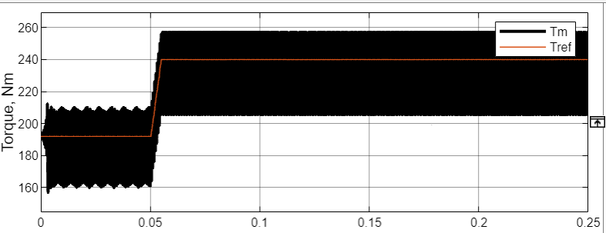

### Notable points:

The introduction of an MPC controller introduce many problems to the system. Even though a respectable efficiency is achieved, the offset is incredibly large in this case due to the amount of noise and oscillation in the system. The resultant torque of the motor has a peak to peak value of over 50. This results in a fairly large power draw and much greater torque ripple, greatly hurting the motors ability to perform.

## MPC Control: Positive Gain / Sinusoidal

|  |  |
| --- | --- |
| Motor Efficiency (%) | 95.79 |
| Power Extracted (Pbat) | 46.77 |
| Average Torque | 180.1 |
| SS Trq Ripple | 0 |
| U Control Load | 0.008738 |
| Current THD | 20.78 |
| Torque Tracking Error | 22.22 |

### Notable points:

After introducing the sinusoidal reference the torque error is actually greatly reduced, however, the model still has considerably worse performance than the PI + decoupler model. The model struggles to find steady state for currents and greatly overshoots the peak target torque consistently. There is also a large current THD, likely causing the errors in torque tracking. There is however a significantly lower power draw from the system at only 46 KW.

## MPC Control: Negative Gain / Step Change

|  |  |
| --- | --- |
| Motor Efficiency (%) | 95.39 |
| Power Extracted (Pbat) | 63.19 |
| Average Torque | 239.9 |
| SS Trq Ripple | 0.02619 |
| U Control Load | 0.006978 |
| Current THD | 0.03741 |
| Torque Tracking Error | 0.02078 |

### Notable points:

After tuning the controller gains, the model performance has significantly improved. The torque tracking is almost perfect with the exception of a small overshoot and a few oscillations. However it does balance out and reach steady state very quickly after this resulting in a very low tracking error. It is important to note however that the torque never reaches a constant steady state value. It continually “ripples”, making wave form patterns, despite idq currents and voltages not following this pattern.

## MPC Control: Sinusoidal / Negative Gain

Deadbeat sinusoidal ref, negative gain

|  |  |
| --- | --- |
| Motor Efficiency (%) | 95.76 |
| Power Extracted (Pbat) | 49.7 |
| Average Torque | 191.2 |
| SS Trq Ripple | 0 |
| U Control Load | 0.005472 |
| Current THD | 15.361 |
| Torque Tracking Error | 11.34 |

### Notable points:

When the sinusoidal reference is introduced again it further proves the increased performance of the system. While yes it does still overshoot the torque request, it is a constant value that still results in a lower power draw, and increased efficiency. Idq has virtually no error with the exception of the previously seen offset.

## VSI: 10khz / Step Change

VSI part 1, step change, 10khz

|  |  |
| --- | --- |
| Motor Efficiency (%) | 95.38 |
| Total Efficiency | 91.6 |
| Power Extracted (Pbat) | 51.56 |
| Average Torque | 192 |
| SS Trq Ripple | 0.004078 |
| U Control Load | 0.00471 |
| Current THD | 0.05156 |
| Torque Tracking Error | 1.962 |

w

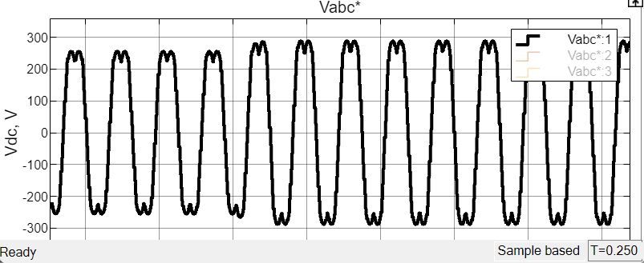

### Notable points:

After converting from the constant VSI model, the performance once again drops despite the voltage and current charts following the expected patterns, the torque has a large amount of noise and never settles at a steady state value. This model also sees a drastic reduction in efficiency. This is expected however due to the introduction of inverter losses and no longer assuming a perfect model.

## VSI: 5KHz / Step Change

5khz: *simulation fails at 0.1 sec*

|  |  |
| --- | --- |
| Motor Efficiency (%) |  |
| Total Efficiency |  |
| Power Extracted (Pbat) |  |
| Average Torque |  |
| SS Trq Ripple |  |
| U Control Load |  |
| Current THD |  |
| Torque Tracking Error |  |

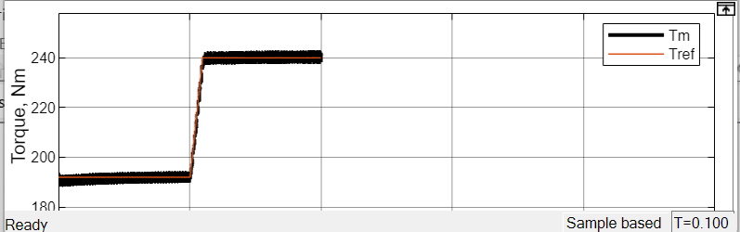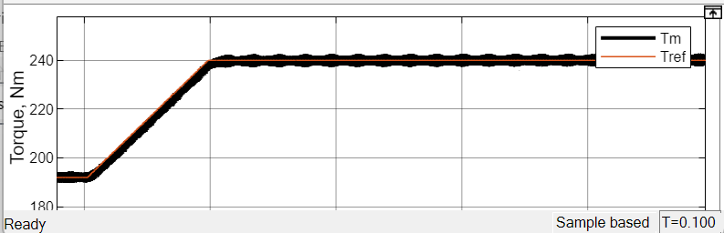

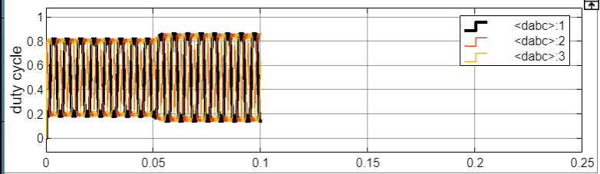

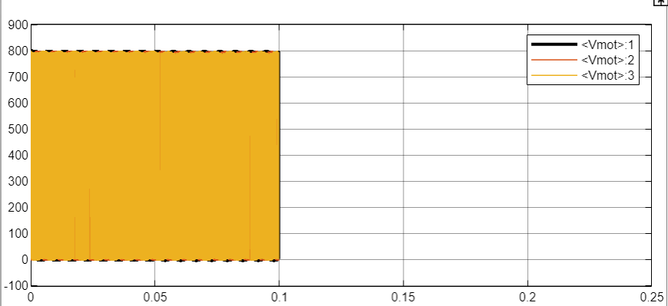

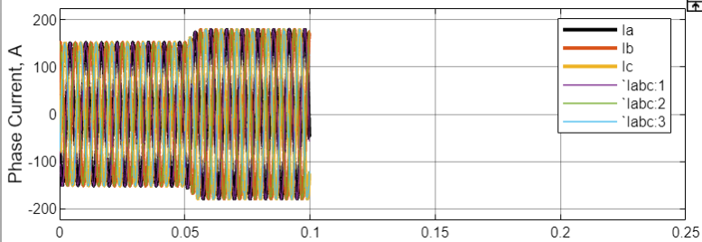

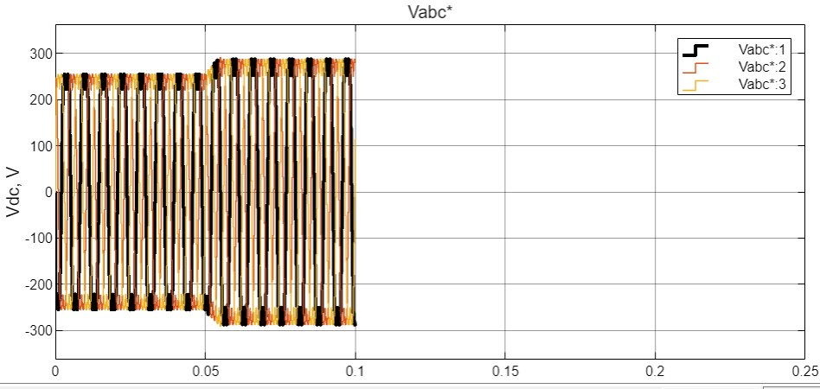

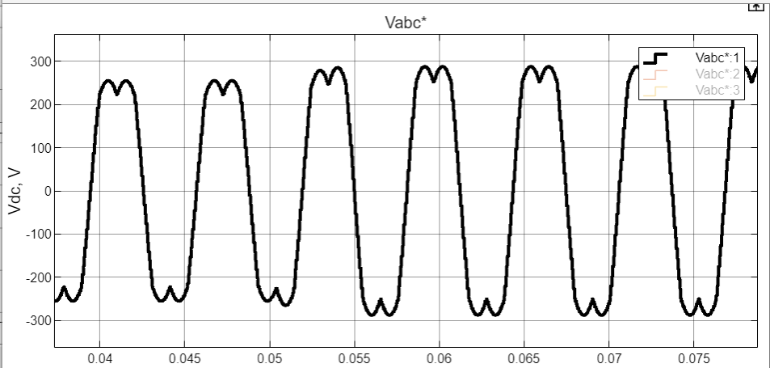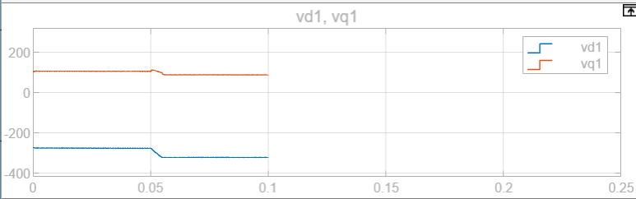

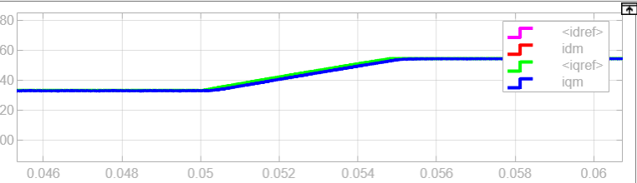

### Notable points:

It is important to note for this model that it failed to run after 0.1 seconds, however, this test was long enough to observe the torque step change, the metrics however were unable to be calculated due to this error. From observation though this model still stuffers from the same noise issues. However, it is clearly less than that of the 10KHz model. This is likely due to the model having less time to process the current command resulting in less delta by the next step change.

## VSI: 20KHz / Step Change

20khz:

|  |  |
| --- | --- |
| Motor Efficiency (%) | 95.38 |
| Total Efficiency | 92.25 |
| Power Extracted (Pbat) | 65.63 |
| Average Torque | 241 |
| SS Trq Ripple | 1.622 |
| U Control Load | 0.005069 |
| Current THD | 2.011 |
| Torque Tracking Error | 7.981 |

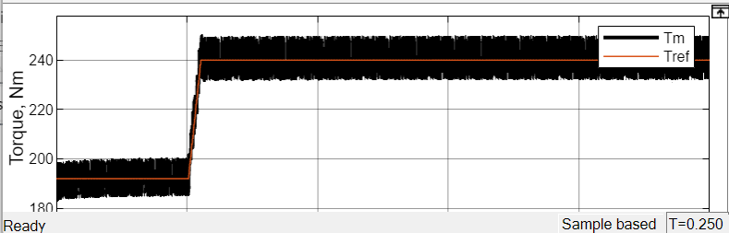

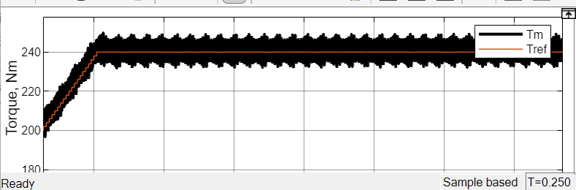

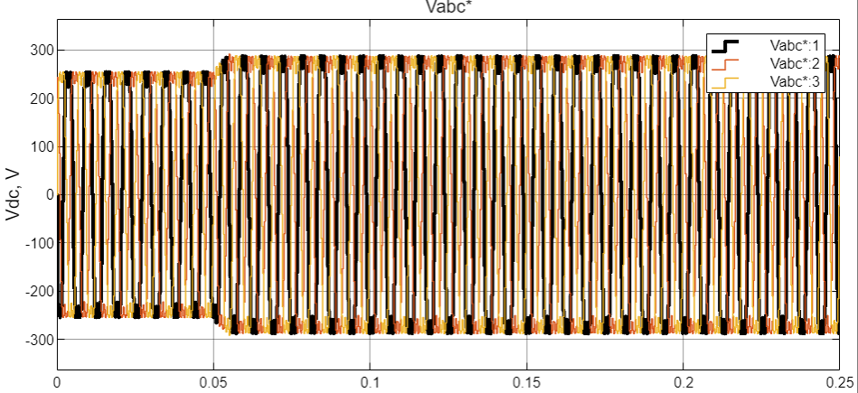

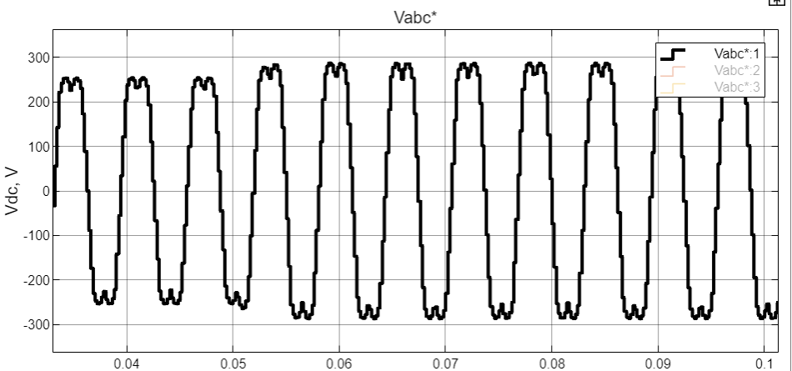

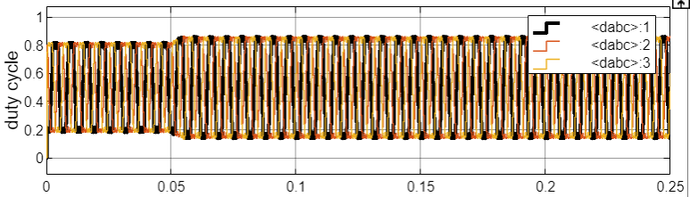

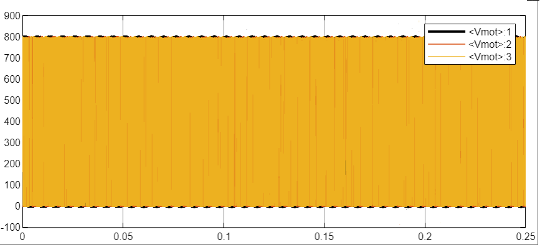

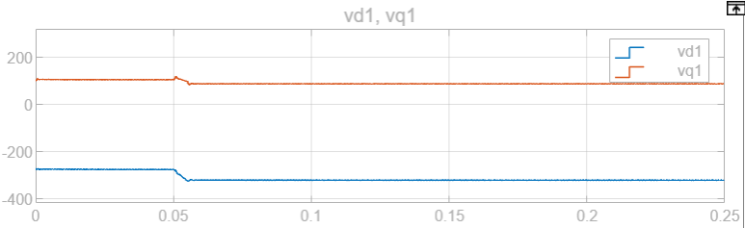

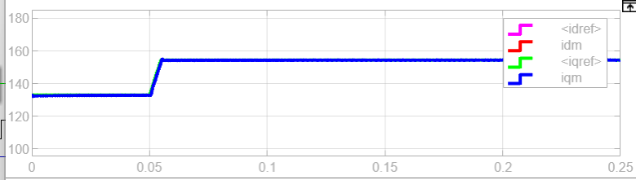

### Notable points:

Doubling the frequency further validates the previous points. The noise has significantly increased compared to the 10KHz, Lilley because the model has more time to accumulate error before trying to rectify itself.

## VSI: 10KHz / Step Change / VDC/2

|  |  |
| --- | --- |
| Motor Efficiency (%) | 91.1 |
| Total Efficiency | 85.75 |
| Power Extracted (Pbat) | 3.717 |
| Average Torque | 12.78 |
| SS Trq Ripple | 2.477 |
| U Control Load | 0.01921 |
| Current THD | 0.5934 |
| Torque Tracking Error | 2.65*10^4 |

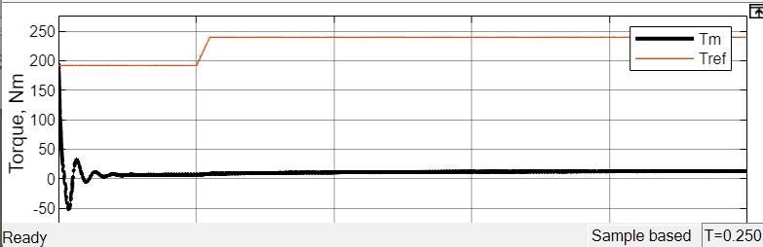

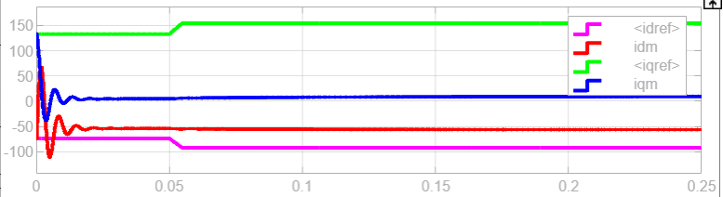

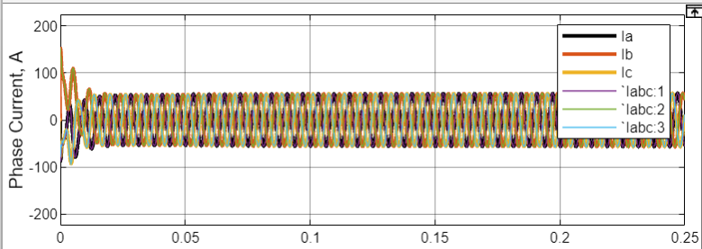

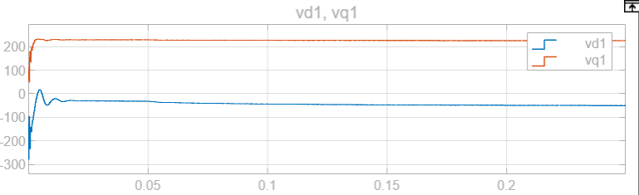

### Notable points:

Reducing the battery voltage by half has rendered the motor essentially useless. Power draw is essentially zero due to the reducing power available to begin with, and the motor is unable to produce the energy required to reach the torque command.

# Conclusion:

Overall, this lab does an excellent job at exploring various control strategies and the affect changing certain parameters will have. It also does an excellent job at exploring other prediction models like MPC and comparing to other methods such as PI and PI + decoupling. This lab will be used as a baseline for my project, giving an excellent starting place for comparing the results to the signal injection method I have chosen. I will also be able to further investigate the MPC model and continue to improve and tune it.